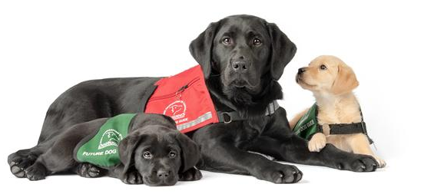


Raise Funds. Inspire Students. Change Lives.

A proven school fundraiser that families are proud to support.
Our annual Dog Guide Puppy Calendar Fundraiser helps your school generate revenue while supporting Canadians living with disabilities.
- No upfront cost
- No payment collection
- We do online setup for you
- No inventory risk
- Easy to promote through email and social media


Earn $10 for Every $20 Calendar Sold
The remaining funds support Lions Foundation of Canada Dog Guides; approximately $3 per calendar covers production and shipping.
Over $500,000 Raised Since 2018
“A great way to teach our students about helping others while raising funds. These adorable calendars practically sell themselves.”
Linda, Peel DSB

More Info: greencapes.com/school or email SchoolProgram@GreenCapes.com

How it works:
- We create your customized online fundraising page.
- Your school shares the link with families.
- We handle payments, shipping and reporting.
- You receive $10 for every calendar sold.
Or if you prefer, purchase calendars for $10 each (minimum 25) and have them on hand for direct sales.
 | The Calendar  - 12-month wall calendar featuring future Dog Guide puppies  - Over 18 gorgeous puppy pictures  - Designed to be displayed and enjoyed all year  - Practical purchase with strong gift appeal  - Lots of space for filling in appointments and notes

Green Capes Lions Club

Green Capes supports Lions Foundation of Canada Dog Guides through fundraising and service. Our members are puppy raisers, graduates and volunteers from across Canada.

Lions Foundation of Canada Dog Guides


Dogguides.com
Lions Foundation of Canada Dog Guides provides service dogs at no cost to Canadians living with disabilities. Each Dog Guide costs approximately $35,000 to breed, train and place, and the Foundation receives no government funding.
Programs: Canine Vision, Hearing, Seizure Response, Diabetes Alert, Service, Autism Assistance and Facility Support.

